Name _______________________ Date _______________

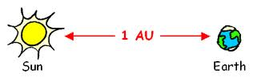
Diameter
Sun 1,391,000

Planet Diameter Distance from the Sun AU TP
Mercury 4,800 km 57,910,000 km 0.4 4
Venus 12,100 km 108,200,000 km 0.7 7
Earth 12,750 km 149,600,000 km 1.0 10
Mars 6,800 km 227,940,000 km 1.5 15
Asteroid belt 414,436,363 km 2.8 28
Jupiter 142,800 km 778,330,000 km 5.2 52
Saturn 120,660 km 1,429,400,000 km 9.6 96
Uranus 51,800 km 2,870,990,000 km 19.2 192
Neptune 49,500km 4,504,000,000 km 30 300

